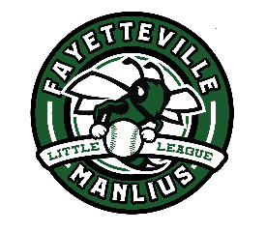
Fayetteville-Manlius Little League
FMLL Board Terms – 2025/2026

Executive Board
Bill Welch - President
Ray Swift - Vice President for Baseball
OPEN - Vice President for Softball
Kari Hammond - Secretary
Mike Doolittle – Treasurer

Board Term Expiring in 2026
Kevin Carroll
Brian Burnett
Russ Corbin
Ira Friedman
Vinnie Kuss
Patricia Chamblee
Jacob Grubka
Andy DiLaura
Jessica Wetsig
Steve Baickle
Darren Grahame
Kevin Carroll
Lee Neitzel

Board Term Expiring in 2027
Kevin Coates
Sean Maney
Mike Doolittle
Erik Hehl
Clare Miller
Graham Nelson
Ray Swift
Adam Kroft
Tim Shore
Aaron Luedtke
Kari Hammond
Mike Lane

Board Term Expiring in 2028
Bill Welch
Don Trombley
Stephen Russell
Jen Modugno
Jess Hehl
Ed Dowling
John Zarella
Heather DiPaolo
Faith Rayland
Dalton Dimon
Bob Calnon
Rich Fisher

